History of St. James the Great, Dursley
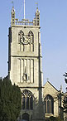
God has been worshipped on the site of St. James The Great for many centuries. It is a place sanctified by prayers of many generations of Christians.
The earliest reference to a church building here is in 1221 when it was a sanctuary church. Part of the south wall of this early church can still be seen. About 1320 the church was enlarged and rebuilt using 'puff' stone, as seen in the two arcades of octagonal columns.
A tower with a spire was built in 1480, new roof put on and the fine perpendicular windows put in. It was a time of great prosperity because of the local woollen trade. However, the spire and tower fell down in 1698 and the tower alone was rebuilt as we now see it in 1707 - 1709.
During the next 150 years the whole church fell into disrepair but it was extensively restored in 1867 when the clerestory was added and the chancel rebuilt and extended. In the 20th century the Victorian fittings have been removed to make the church more suited to modern liturgy.
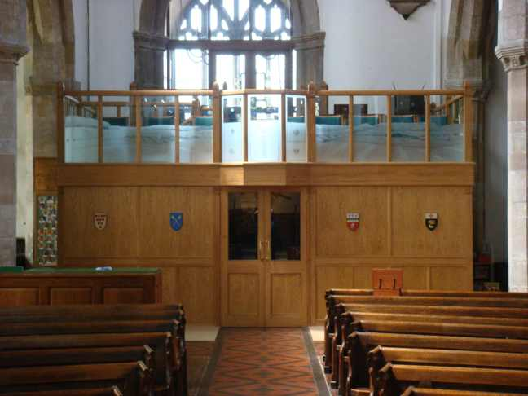
In the 21st century major restoration and renovation work was undertaken to repair and conserve the structure of the building, to improve the lighting and sound system and to create the West End Gallery Suite (formerly known as the Tardis!) providing a kitchenette, disabled toilet, storage rooms and a gallery. During this phase the font was moved to the south aisle and a mosaic set into the floor where the font stood. A children’s mosaic was created at the same time and is displayed on the west wall of the church in the children’s area.
