History of St Marks, Woodmancote
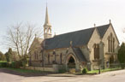
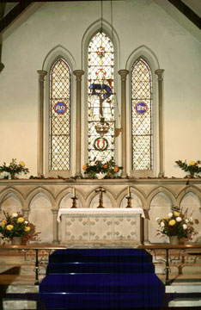
St. Mark's church was consecrated on 16th April 1844 and was presumed open for worship in 1847 when the first church wardens were appointed. The church was built partly to accommodate the poor people of the parish who could not afford to purchase a privately-owned pew in the parish church. Many people of the area did not have enough money for food and clothing let alone a sufficient to pay a pew rent especially since the collapse of the woollen trade in the area. However, thanks to the great benefactor and philanthropist Henry Vizard, who gave the land to the Diocese for the church and burial ground, St.Mark's was built.
Although St. Mark's Church did not become a separate ecclesiastical parish, Woodmancote was a separate manor from Dursley and, in those days, has quite a distinct entity of its own. It did, therefore, operate rather like a village church with a close knit congregation.
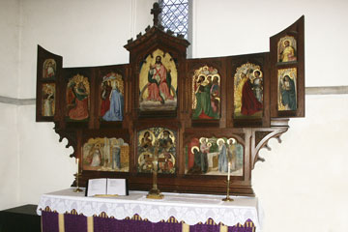
Several improvements to the church were undertaken in the 1980's when full responsibility for the financial affairs of St.Mark's was vested in the Chapel Wardens. At that time the windows were repaired, the interior was redecorated and the roof repaired. In 1994 the Omega Rooms were dedicated to the memory of June Beard and Sidney Talboys.
Sadly attendance at this church has significantly declined over the last few years and it’s future is now being considered by the Diocese (2019)

